Biometry Midterm Part 1: Writing About Data
Introduction:
Over the last several decades, the combined pressures of global climate change and local anthropogenic impacts have resulted in marked worldwide declines in reef-building stony coral populations (Liberman et al., 2025; Tebbett et al., 2023). This trend has been particularly pronounced in the Caribbean (Jackson et al., 2014), where continued losses have been attributed to repeated acute disturbances, such as hurricanes, disease outbreaks, and thermal stress events, as well as chronic pressures like increasing sea surface temperatures (Martinez-Quintana & Lasker, 2021). However, in contrast to stony corals, non-reef-building octocorals have demonstrated resilience under these same conditions.
While octocorals have always been among the most dominant taxa on shallow (< 30m depth) Caribbean reefs (Kinzie III, 1979), recent increases in octocoral abundance have been documented throughout the region (Sanchez et al., 2019; Lenz et al., 2015), including in the Florida Keys (Ruzicka et al., 2013). Though some have suggested that this shift toward octocoral community dominance may represent a “new normal” (Lasker et al., 2020), it's unclear whether these reefs will endure as an alternative stable state or are simply ecological “placeholders” on the “slippery slope to slime” (Pandolfi et al., 2005).
Octocorals’ ecological resilience has been at least partially attributed to persistently high levels of recruitment, particularly following acute disturbances (Lasker et al., 2020; Liberman et al., 2025). However, octocorals have received relatively little research attention compared to stony corals (Kupfner Johnson & Hallock, 2020), and the ecological processes driving their resilience and recruitment are still poorly understood (Lasker et al., 2020). Recent studies comparing long-term trends in adult density, recruitment, and disturbance response on Florida’s Coral Reef (FCR) have either grouped data across data across species and size classes (Liberman et al., 2025) or been limited to a smaller study range in Southeast Florida and subset of species (Jones et al., 2024). This project aims to assess the individual trends in recruitment, survival, and community size structure of five target species using a long-term dataset from sites across FCR from 2012 to 2025.

Methods:
This study utilizes data collected as part of the Coral Reef Evaluation and Monitoring Project (CREMP), which monitors the health status and demographic trends of selected coral reefs along FCR. Initiated in 1996, the project expanded in 2011 to include annual octocoral surveys. These surveys include a tally of all arborescent octocoral colonies as well as maximum height and health information for five target species (Antillogorgia americana, Antillogorgia bipinnata, Eunicea flexuosa, Pseudoplexaura porosa, and Gorgonia ventalina).
Surveys are conducted along 10 x 1 m permanent transects at 20 sites in the Florida Keys and 12 sites in the Dry Tortugas. Study sites in the Florida Keys are stratified across three sub-regions, the Lower (n = 6), Middle (n = 8), and Upper Keys (n = 6). These sites are also stratified across three habitat types, patch reefs (n = 6), shallow forereefs (n = 7), and deep forereefs (n = 7). The Dry Tortugas are not subdivided into sub-regions and contain only two habitat types, patch reefs (n = 9) and deep forereefs (n = 3).
Initial dataset cleaning was conducted using the R package “dplyr” (Wickham et al., 2026) and included standardizing column names across the demographic conditions and total density tally datasets and limiting the data to samples collected between 2012 and 2025. In addition, the conditions dataset was filtered to reflect the current CREMP target species and species codes. Preliminary data exploration included using “dplyr” to generate summary tables for variables of interest and the R package “ggplot2” (Wickham 2016) to visualize their distributions.

Results:
Total arborescent octocoral densities varied across sub-region and habitat. The Upper Keys had the highest mean density of any subregion (19.14 colonies m2 ± 11.7), followed by the Middle Keys (15.52 colonies m2 ± 10.54), the Lower Keys (11.24 colonies m2 ± 9.43), and the Dry Tortugas (7.62 colonies m2 ± 8.46). Mean total densities were highest at shallow forereefs in the Middle and Upper Keys, and at deep forereef sites in the Lower Keys and Dry Tortugas. Total densities gradually decreased over time across subregions and habitat types, with one noticeable dip following Hurricane Irma in 2017, followed by an apparent recruitment boom between 2020-2022, and then a steep decline following Hurricane Ian in 2023 and the 2024 marine heatwave (Figure 1).
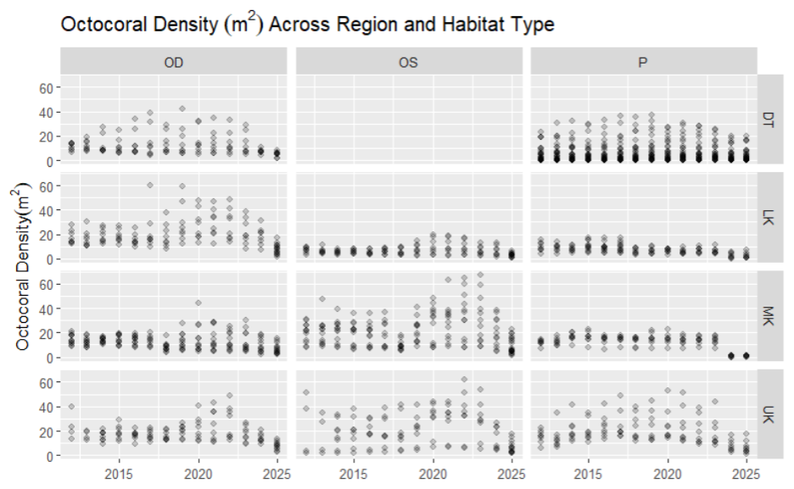Figure 1: Total arborescent octocoral density m2 in 11 regional habitats on Florida’s Coral Reef. Habitat type is organized in the top panel by deep forereef (OD, left), shallow forereef (OS, middle) and patch reef (P, right).

These trends are also noticeable when considering the total number of target colonies observed per year (Figure 2). In general, the proportion of colonies belonging to each target species was consistent throughout the study period, with Antillogorgia americana and Gorgonia ventalina in the highest abundance, followed by Antillogorgia bipinnata, Eunicea flexuosa, and then Pseudoplexaura porosa.
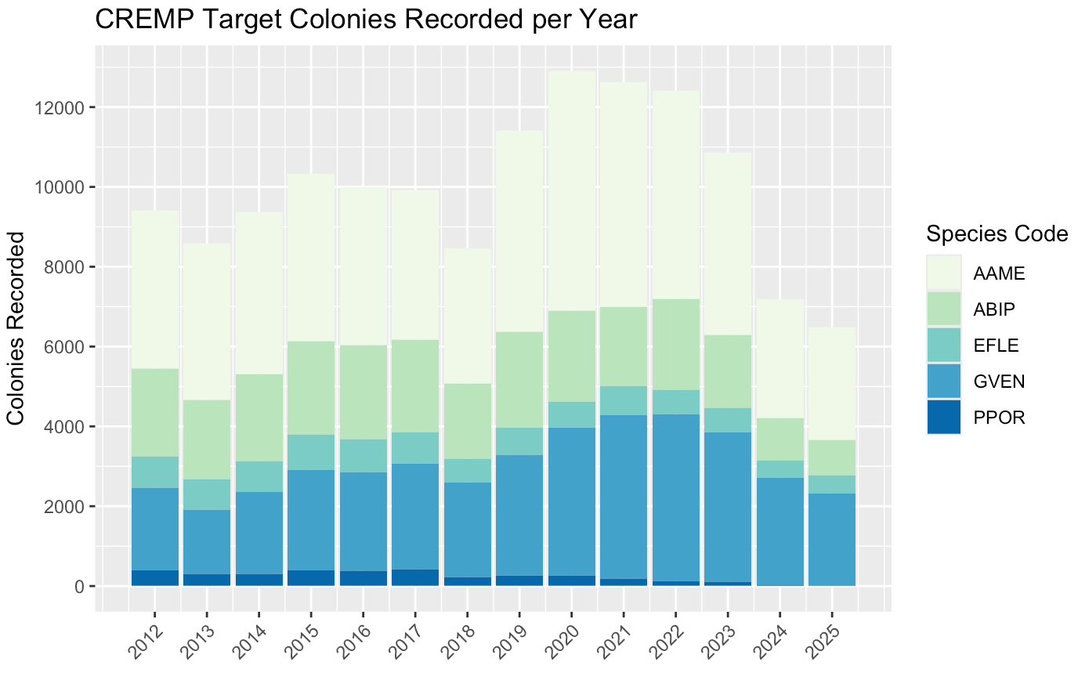
Figure 2: Total number of target colonies observed per year from 2012-2025. Bars are colored in proportion to the number of colonies in each target species: Gorgonia ventalina (GVEN), Antillogorgia americana (AAME), Antillogorgia bipinnata (ABIP), Eunicea flexuosa (EFLE), and Pseudoplexaura porosa (PPOR).

Works Cited:
FWC Coral Research Program. (2022). Florida Keys Coral Reef Evaluation Monitoring Project CSV Files Download [data files]. Florida Fish and Wildlife Conservation Commission-Fish and Wildlife Research Institute [producer]. https://geodata.myfwc.com
FWC Coral Research Program. (2022). Dry Tortugas Coral Reef Evaluation Monitoring Project CSV Files Download [data files]. Florida Fish and Wildlife Conservation Commission-Fish and Wildlife Research Institute [producer]. https://geodata.myfwc.com
Jackson, J., Donovan, M., Cramer, K., & Lam, V. (2014). Status and Trends of Caribbean Coral Reefs: 1970-2012. https://doi.org/10.13140/2.1.4868.6726
Jones, N., Leinbach, S., & Gilliam, D. (2025). Interspecific variation in demographics reveals ecological winners and losers in a highly disturbed coral reef system. Coral Reefs. https://doi.org/10.1007/s00338-025-02681-2
Kinzie III, R. A. (1973). Coral Reef Project—Papers in Memory of Dr. Thomas F. Goreau. 5. The Zonation of West Indian Gorgonians. Bulletin of Marine Science, 23(1), 93-155.
Kupfner Johnson, S., & Hallock, P. (2020). A review of symbiotic gorgonian research in the western Atlantic and Caribbean with recommendations for future work. Coral Reefs, 39(2), 239-258. https://doi.org/10.1007/s00338-020-01891-0
Lasker, H., Bramanti, L., Tsounis, G., Edmunds, P., & Riegl, B. (2020). The rise of octocoral forests on Caribbean reefs. Population Dynamics of the Reef Crisis, 87, 361-410. https://doi.org/10.1016/bs.amb.2020.08.009
Lenz, E., Bramanti, L., Lasker, H., & Edmunds, P. (2015). Long-term variation of octocoral populations in St. John, US Virgin Islands. Coral Reefs, 34(4), 1099-1109. https://doi.org/10.1007/s00338-015-1315-x
Liberman, R., Hiley, A., Huebner, L. K., Colella, M. A., Ruzicka, R. R., Gilliam, D. S., & Jones, N. P. (2025). Octocoral dynamics over a decade on Florida’s coral reef. Scientific Reports, 15(1), 37635. https://doi.org/10.1038/s41598-025-21610-5
Martínez-Quintana, A., & Lasker, H. (2021). Early Life-History Dynamics of Caribbean Octocorals: The Critical Role of Larval Supply and Partial Mortality. Frontiers in Marine Science, 8. https://doi.org/10.3389/fmars.2021.705563
Pandolfi, J. M., Jackson, J. B. C., Baron, N., Bradbury, R. H., Guzman, H. M., Hughes, T. P.,…Possingham, H. P. (2005). Are US coral reefs on the slippery slope to slime? In (Vol. 307, pp. 1725-1726): American Association for the Advancement of Science.
R Core Team (2023). _R: A Language and Environment for Statistical Computing_. R Foundation for Statistical Computing, Vienna, Austria. https://www.R-project.org/
Ruzicka, R., Colella, M., Porter, J., Morrison, J., Kidney, J., Brinkhuis, V.,…Colee, J. (2013). Temporal changes in benthic assemblages on Florida Keys reefs 11 years after the 1997/1998 El Nino. Marine Ecology Progress Series, 489, 125-141. https://doi.org/10.3354/meps10427
Sánchez, J., Gómez-Corrales, M., Gutierrez-Cala, L., Vergara, D., Roa, P., González-Zapata, F.,…Sarmiento, A. (2019). Steady Decline of Corals and Other Benthic Organisms in the SeaFlower Biosphere Reserve (Southwestern Caribbean). Frontiers in Marine Science, 6. https://doi.org/10.3389/fmars.2019.00073
Tebbett, S. B., Connolly, S. R., & Bellwood, D. R. (2023). Benthic composition changes on coral reefs at global scales. Nature Ecology & Evolution, 7(1), 71-81. https://doi.org/10.1038/s41559-022-01937-2
Wickham, H., Chang, W., Henry, L., Pedersen, T. L., Takahashi, K., Wilke, C., Woo, K., Yutani, H., Dunnington, D., & van den Brand, T. (2024). ggplot2: Create elegant data visualisations using the grammar of graphics (Version 3.5.1) [Computer software]. CRAN. https://r-project.org
Wickham, H., François, R., Henry, L., Müller, K., & Vaughan, D. (2026). dplyr: A Grammar of Data Manipulation (Version 1.2.1) [Computer software]. CRAN. https://CRAN.R-project.org/package=dplyr

